MES Process
- Current Process
The production process in our discrete manufacturing operation is carried out through the Manufacturing Execution System (MES) in our ERP system (Odoo MRP). The typical process is as follows:
⚬ Detection and Interruption: In case there is a deviation that is not in tolerance, the machine operator stops the ongoing work order in the shop floor terminal.
⚬ Informal Defect Report: To ensure cycle time efficiency, the operator does not go down the nested taxonomy menu tree, but rather writes an informal text in the work order note or failure message popup (e.g., "spindle vibration at step 2, insert chipped").
⚬ Quarantine: The WIP part is given a red routing label and put to the quarantine staging floor. At the same time, the work order is placed on Hold in the database.
⚬ QA Triage Batch: There are triage batches conducted by QA engineers twice a week. They export the raw MES failure logs into spreadsheets and interpret the free text by translating the operators' slang and abbreviations into ISO 14224 failure modes.
⚬ Maintenance Request: After classification of defects, the QA engineer generates a work order for maintenance in the ERP.
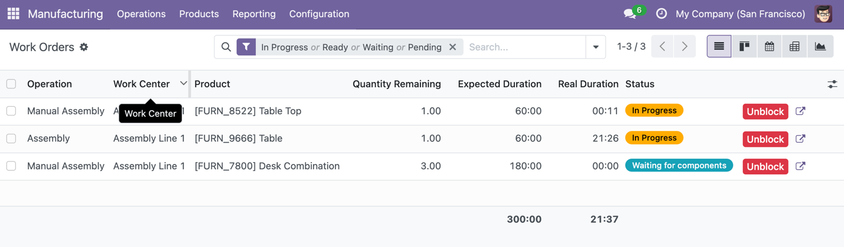
[Machine Station] ──> [Operator Stops WO] ──> [Enters Free-Text Note] ──> [Part to Quarantine]
│
(3-Day Batch Wait Time)
│
[Maintenance Dispatched] <── [Manual ISO Code Mapping] <── [QA Engineer Reads Log]

Work Order Ref | Product / Assembly | Work  Center | Planned  Duration | Logged Loss  Reason | Operator  Free-Text  Input | Triage  Latency | Downstream  Impact
WH/MO/00002 | [FURN_9666] Table | Assembly  Line  1 | 60:00  min | Equip  ment  Failure | "Toolin  g  chatter  on  step 2,  tool  insert  T3  chippe  surfac  e  roughn  ess  high" | 72  hours | Line halted  At 21:26;  2 parent  orders  blocked
WH/MO/00001 | [FURN_8522]  Table Top | Assembly  Line  1 | 60:00  min | Equip  ment  Failure | "Statio  n 02:  Spindl  e  vibrati  onal  chatter  on  step 2" | 68  hours | Starved;  stopped at  00:11
WH/MO/00003 | [FURN-7800]  Desk Combo | Assembly  Line  1 | 180:00  min | Pending | Blocked by  upstream line  occupancy |  | 3 units  delayed; 180  minutes  idle time

Figure 1.1: Odoo MES Work Center Tablet View showing unstructured free-text operator defect input.

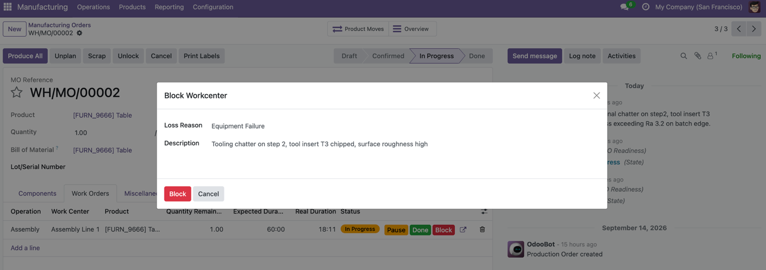
Figure 1.2: Odoo Manufacturing Order status screen displaying unclassified blocked production line.
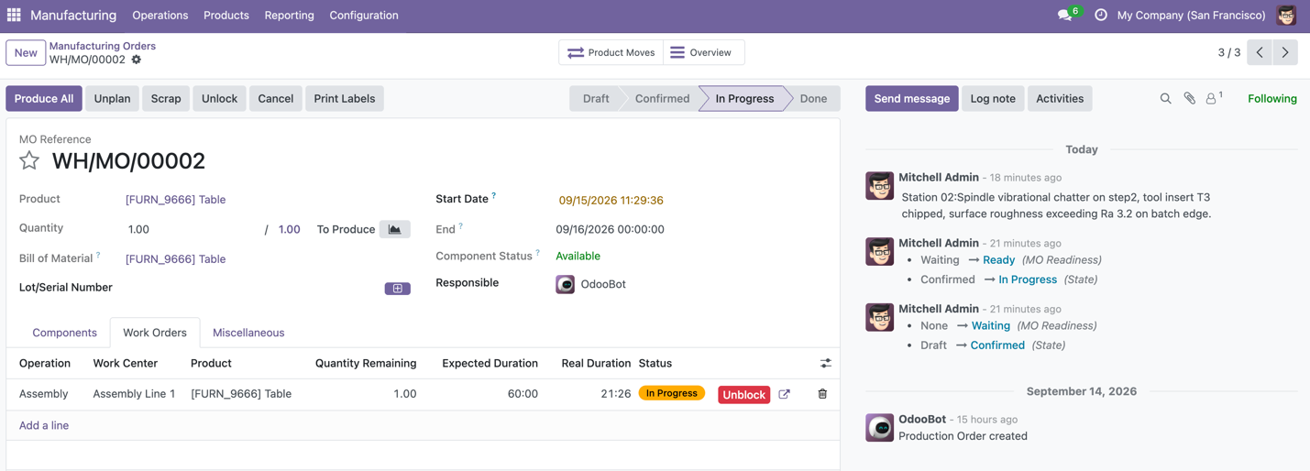

- Pain Point
⚬ Unstructured Data Graveyard: Operators enter subjective phrases for identical physical failures (e.g., "shaking," "chatter," "vibrational squeal," "loose head"). Standard relational queries (SELECT WHERE defect_code = ...) fail completely, leaving the enterprise data architecture blind to real-time shop-floor realities.
⚬ Triage Time Delays: Due to manual QA batch processing of defect reports, the average triage time delay ranges from 48 to 72 hours after the start of the tooling failure until the maintenance department gets a formal ticket for repair.
⚬ Compounding Work-Center Starvation and Scrap: When an unclassified defect halts a station (shown in Figure 1.2), the operational blockage cascades across shared resources. As captured in the Work Orders queue, halting Assembly Line 1 for order WH/MO/00002 immediately froze 300 planned operating minutes (5.0 machine hours) across three queued assembly orders (FURN_8522, FURN_9666, and FURN_7800). Furthermore, during the 72-hour triage latency, if an operator clears the block without root-cause tooling replacement, the station produces up to 24 defective units per day, escalating direct material scrap by an estimated $1,200 to $3,500 per incident.

3. Problem Statement
"The reliance on generic categorical dropdowns ('Equipment Failure') and unindexed free-text logs during work-center stoppages induces a 72-hour QA triage latency. This data opacity currently strands up to 5.0 hours of active machine queue capacity per stoppage event, driving an average 4.6% recurring scrap rate and approximately $18,500 in monthly rework, downtime, and material scrap."

- Potential GenAl Solution
⚬ Real-Time Semantic Extraction: An on-premise or edge-hosted LLM ingests free-text notes of operator upon submission, extracts failure symptoms, and standardizes them into structured schema fields(ISO failure codes) stored in PostgreSQL.
⚬ Mulit-Modal SOP & Maintenance Retrieval (RAG): The system combines the parsed failure code with machine telemetry(RPM, runtime hours) and queries machine operating manuals and historical repair tickets using a vector store to identify the most probable root cause.

⚬ Automated Action Proposal: The AI generates a 3-step diagnostic action checklist directly on the operator’s tablet (e.g., "1. Inspect insert T3 for edge chipping; 2. Verify collet torque to 45 Nm"), while auto-drafting an urgent maintenance ticket if severity thresholds are breached.

